# CSA0989 PROGRAMMING IN JAVA

## JAVA ASSIGNMENT

**Smart Traffic Signal Optimization:**

Smart Traffic Signal Optimization aims to improve traffic flow and reduce congestion using real-time data and adaptive signal control. The system uses sensors and cameras to gather traffic data, processes it with algorithms, and adjusts traffic signals dynamically. Here are key components and benefits of such a system:

**Pseudo Code Implementation**

Initialize sensors and cameras

Initialize traffic signal controllers

Initialize central processing unit (CPU)

Function collectTrafficData():

For each sensor and camera:

Read traffic data

Send data to CPU

Function processTrafficData(data):

Analyze traffic patterns

Predict traffic flow

Calculate optimal signal timings

Function updateTrafficSignals(timings):

For each traffic signal controller:

Set signal timings based on calculated timings

Function main():

While system is running:

trafficData = collectTrafficData()

signalTimings = processTrafficData(trafficData)

updateTrafficSignals(signalTimings)

Wait for a predefined interval

**Data Flow Diagram**

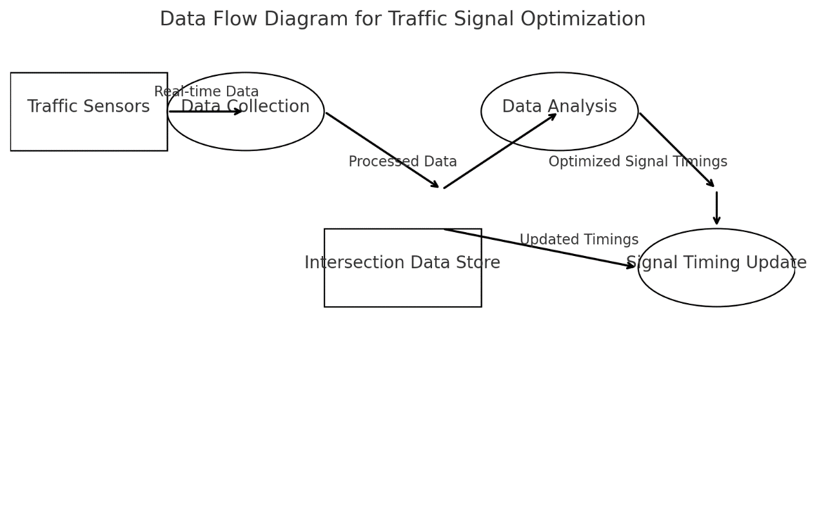

**DOCUMENTATION :-**

• Objective: Optimize traffic signal timings using real-time sensor data.

• System Components:

* Traffic Sensors: Collect vehicle and pedestrian counts.
* Modules: Data Collection, Data Analysis, Optimization, Traffic Signal Control.
* Data Store: Stores traffic data and signal settings.
* User Interface: For monitoring and manual control.

• Data Flow:

* Collection → Storage → Analysis → Optimization → Implementation.

• Algorithms:

* Adjust signal timings based on traffic and pedestrian data.

• Considerations & Improvements:

* Scalability: Add more sensors/intersections.
* Future Enhancements: Predictive analytics and advanced algorithms.

**CONCLUSION**

• **Real-Time Data Collection:** The system continuously gathers data from various sensors, providing up-to-date information on traffic and pedestrian volumes.

• **Dynamic Signal Adjustment:** Based on the analyzed data, signal timings are adjusted dynamically to optimize traffic flow and minimize waiting times for vehicles and pedestrians.

• **Centralized Data Store:** The Intersection Data Store maintains the latest traffic data and signal settings, facilitating quick retrieval and updates.

• **Scalability and Flexibility:** The modular design allows for easy integration of additional sensors and intersections, as well as potential future enhancements like machine learning-based prediction models.

• **User Interface and Monitoring:** An intuitive interface enables traffic managers to monitor conditions, make manual adjustments if necessary, and receive alerts for unusual patterns or system malfunctions.

**5. User Interface:**

**-**Dashboard: A user-friendly interface displays real-time traffic conditions and signal timings, providing traffic managers with actionable insights.

- Alerts: Notifications or alerts are sent to traffic managers for any anomalies or necessary interventions, ensuring timely responses to unexpected situations.

In conclusion, this smart traffic signal management system integrates advanced technologies and data-driven approaches to optimize traffic flow in busy city environments. By continuously collecting, analyzing, and acting on real-time data, the system can significantly reduce congestion, enhance travel efficiency, and improve overall urban mobility.